**Day 2 – Learning Summary Answers**

**1.What is the purpose of the core module in AEM?**

**Ans:** The **core** module contains the Java code and business logic. It holds OSGi components such as services, servlets, and scheduled jobs that run inside AEM.

**2.What kind of files and code can be found in the core folder?**

**Ans:** Java source files (classes), OSGi annotations/configurations, and sometimes unit tests. This module is built into an OSGi bundle (a JAR file) that is deployed to AEM.

**3.Explain the role of ui.apps in AEM projects.**

**Ans:** The **ui.apps** module packages all the front-end and repository content. It includes components, dialogs, client libraries (CSS/JS), and other configuration files. These files get installed into AEM’s repository (typically under /apps/yourproject).

**4.How are components structured in the ui.apps folder?**

* **Ans:** Components in ui.apps are usually organized in folders. Each component folder contains:
  + **HTL (HTML Template Language) files** that define the component’s view.
  + **XML files** that define dialogs (for authoring) and properties.
  + **Client libraries** (if required) that provide CSS and JavaScript.

**Hello World Component:**

* Where is the Hello World component located in both core and ui.apps?

**Ans:**

**In Core:**  
The Java implementation of the Hello World component (for example, an OSGi service or servlet) is in the core module.

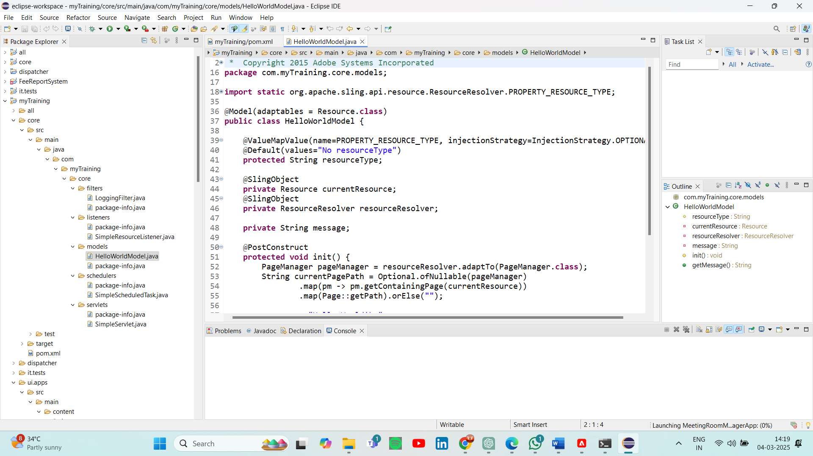

**In ui.apps:**  
The presentation part (HTL script and component configuration) is in the ui.apps module under a component folder.

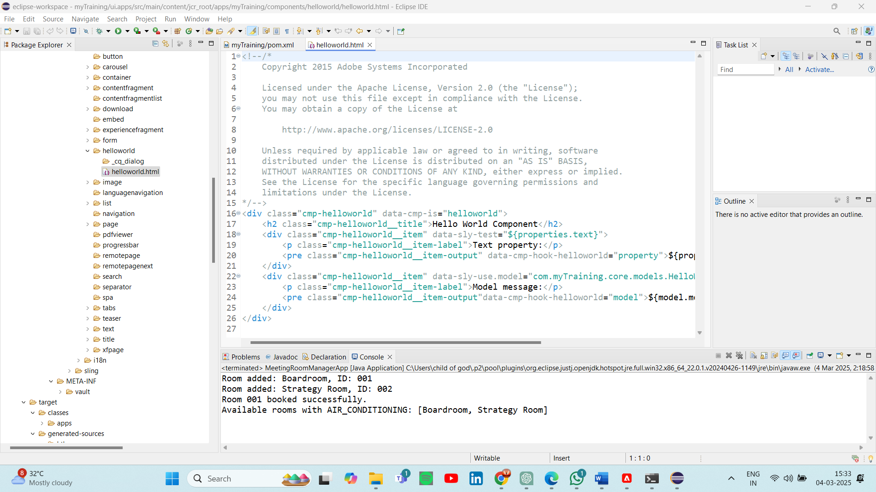

* Explain the Java class (in core) for the Hello World component.

**Ans:** This class might register itself as an OSGi component. It could provide a simple method or service that returns a "Hello World" message or logs the message. The class is compiled into an OSGi bundle that AEM runs.

* How does the HTL script work in ui.apps for Hello World?

**Ans:** The HTL file (e.g., helloWorld.html) is used to render the Hello World message on a page. It typically retrieves data (if needed) from the Java class or uses static text.

* How are properties and dialogs defined for this component?

**Ans:**

The component’s configuration is defined using XML files:

* + **Properties:** Define default values and settings.
  + **Dialogs:** Define the authoring interface (what fields an author can edit in the AEM Touch UI).

**5.What are the different types of AEM modules (core, ui.apps, ui.content, etc.)?**

**Ans:**

* core: Contains backend Java code and OSGi services.
* ui.apps: Contains front-end components, dialogs, and client libraries that are installed into the AEM repository.
* ui.content: Often includes sample content or content configuration.
* ui.config: Holds configuration settings and design properties.

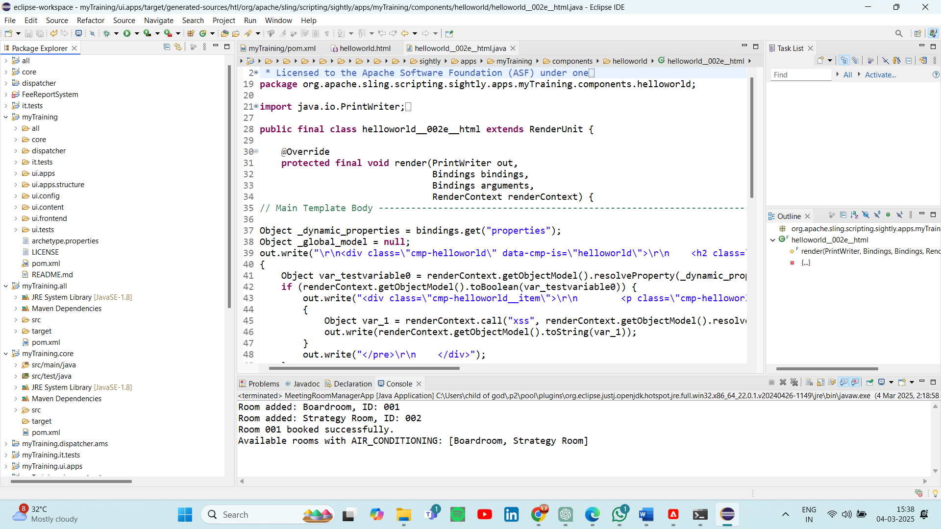

**6.How does Maven build these modules?**

**Ans:**

Maven is set up as a multi-module project where a parent POM aggregates all modules. It processes each module in order:

* **core:** Compiles Java code and packages it as an OSGi bundle (JAR).
* **ui.apps:** Packages the repository content as a ZIP file (content package).
* **Other modules** (like ui.content) are built similarly based on their role.

**7.Explain the build lifecycle of Maven in the context of AEM.**

**Ans:**

• **clean:** Deletes old build files.

• **compile:** Compiles source code.

• **package:** Creates artifacts (JARs, ZIPs).

• **install:** Places the artifacts into your local Maven repository.

• **deploy:** With specific profiles, packages can be automatically deployed to AEM.

**8.How are dependencies managed in pom.xml?**

**Ans:** The pom.xml files list all dependencies and plugins needed for the project. Maven downloads these libraries automatically from remote repositories, ensuring the project is built with the correct versions.

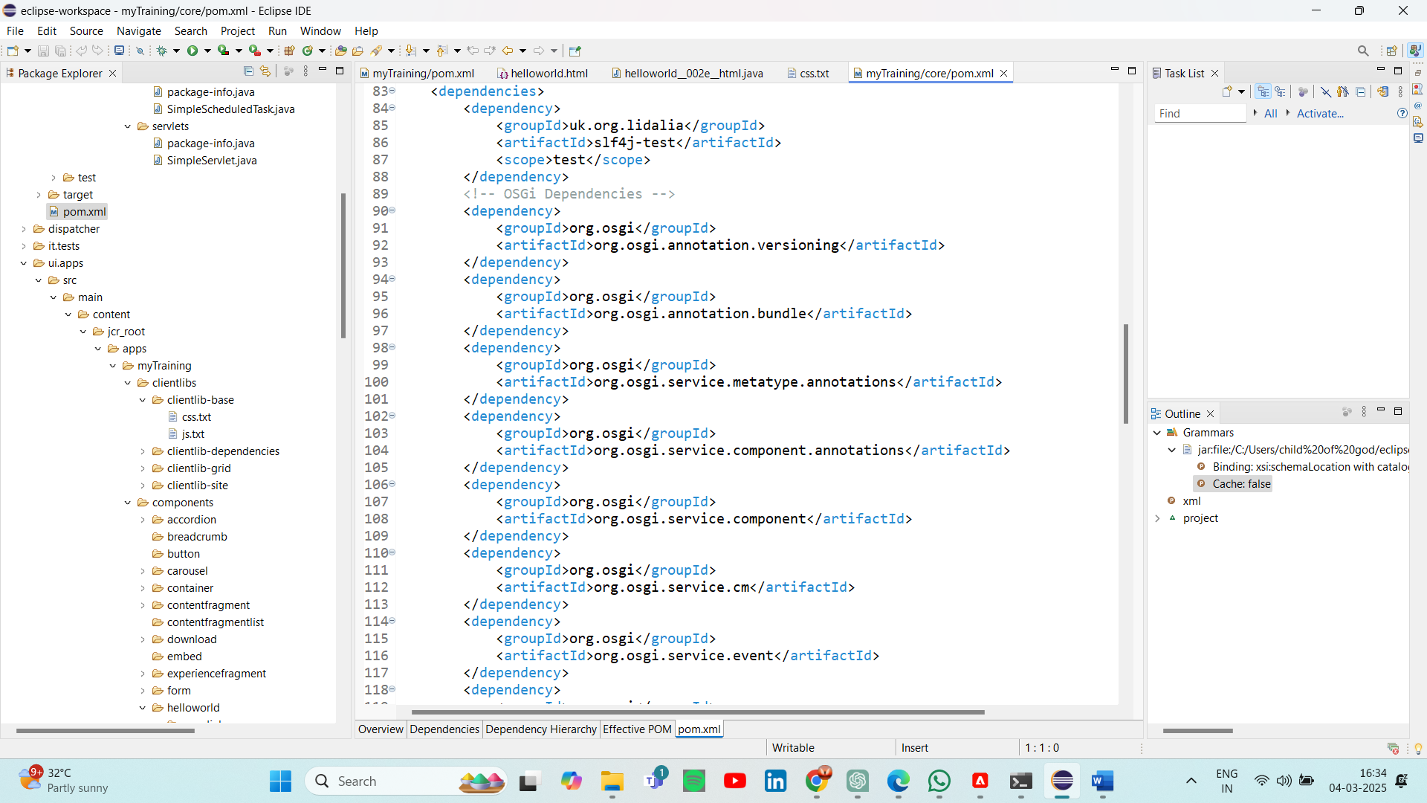

**9.Why is Maven used instead of other build tools?**

**Ans:** Maven is widely used because it standardizes project structure, automates builds and deployments, and manages dependencies and plugins seamlessly. It simplifies complex multi-module builds typical of AEM projects.

**10.What advantages does Maven offer for AEM development?**

**Ans:**

-> Easy management of dependencies and plugins.

-> Consistent build processes.

-> Integration with continuous integration systems.

-> Simplified deployment (using Maven profiles).

**11.How does Maven help in managing dependencies and plugins in AEM projects?**

**Ans:** Maven uses the pom.xml file to manage dependencies and plugins. It automatically downloads needed libraries and handles version conflicts, ensuring consistency. Plugins then standardize the build, compile, package, and deploy processes in AEM projects.

**12.What does mvn clean install do in an AEM project?**

**Ans:** This command cleans previous build artifacts, compiles the code, packages the modules, and installs the artifacts in your local repository.

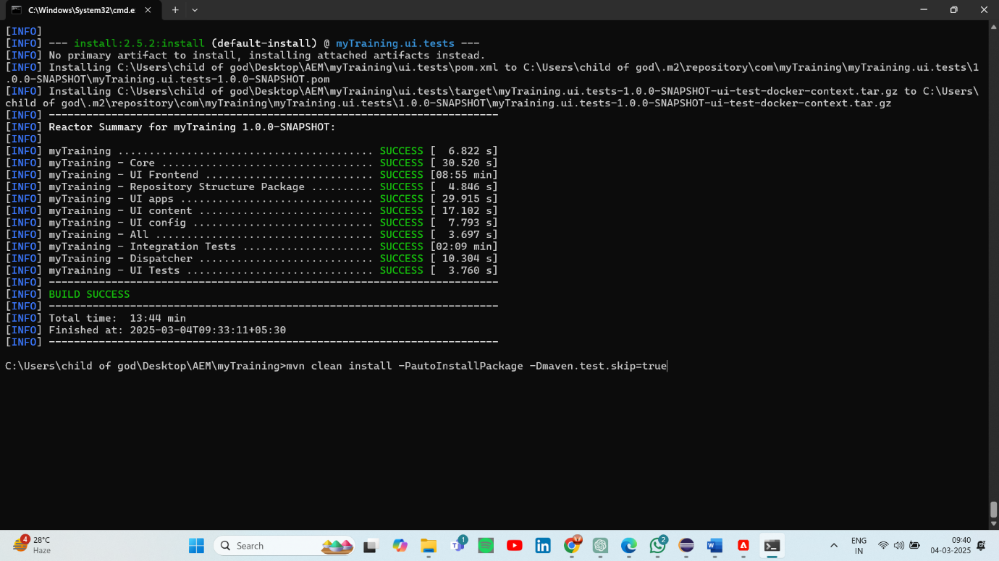

**13.How to deploy packages directly to AEM using Maven commands?**

**Ans:** Maven profiles like autoInstallPackage or autoInstallBundle can be activated (e.g., with -PautoInstallPackage) to automatically upload the content package or OSGi bundle to AEM via HTTP. This streamlines testing and deployment.

**14.Explain the purpose of different Maven profiles in AEM (autoInstallPackage, autoInstallBundle).**

**Ans:**

-> autoInstallPackage: Automatically deploys the ui.apps package to AEM.

->autoInstallBundle: Automatically deploys the core bundle to AEM. These profiles allow you to build and deploy your changes in one command.

**15.What is the purpose of dumplibs in AEM?**

**Ans:** The dumplibs function is used to extract and verify the final output of client libraries (CSS/JS). It helps developers check that all client-side assets are correctly aggregated and minified.

**16.How can you view client libraries using dumplibs?**

**Ans:** By using this url http://localhost:4502/libs/granite/ui/content/dumplibs.html

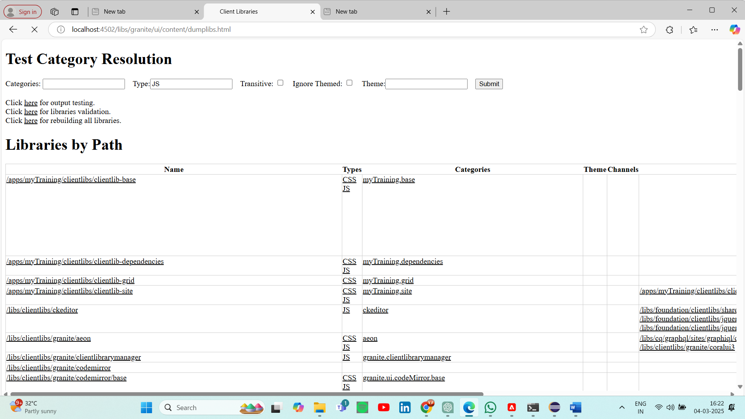

**17.Explain how client libraries are structured in AEM.**

**Ans:**

Client libraries are organized in folders (often under /apps/yourproject/clientlibs). Each library typically contains:

* **CSS files:** Listed in a css.txt file.
* **JavaScript files:** Listed in a js.txt file.
* **Additional resources:** Such as images or fonts. The text files control the order of inclusion when the client library is rendered.

